

**BAN/HR/APPT/20/429**

**November 04, 2020**

**Rajkamal Rajendran Pillai**

**Employee ID: 111262**

**Dear Rajkamal,**

This has reference to our letter no. **GDC/BAN/RMG/OFFER/2020/308** dated **28th** **October, 2020.** We are pleased to offer you employment with us on the following terms andcondition:

**1. Position**

The company shall employ you as **"Architect"** with effect from **November 02, 2020.**

**2. Compensation**

Your annual compensation package would be **Rs. 32,00,000/-(Rupees Thirty Two Lakhs** **Only)**.

The detailed break-up of your salary is as per Annexure A.

1. **Your initial place of posting is at Infogain India Pvt. Ltd.**

**#7, 18th Main Road, 7th Block,Koramangala,Bengaluru - 560095**

1. **Duties and Responsibilities**

4.1 Your job description & responsibilities includes but would not be limited to the following:

1. Working within company's operative policies set / laid from time to time
2. Job assigned to you by your Supervisor from time to time
3. Participating and growing with the company by taking initiative in bringing opportunities
4. Reducing wastage of money or resources, giving suggestions to improve the working environment

4.2 The company will expect you to work with full devotion, sincerity, honesty diligently to the satisfaction of the Company.

4.3 You shall undertake such duties and exercise such power in relation to the Company and its business (as may be specified by your supervisor/senior). You will also undertake

such other duties and powers as your supervisor/seniors in the company from time to time directs in writing or orally.

4.4 In the discharge of such duties and in the exercise of such powers you shall observe and comply with the duties assigned to you as per the business need of the organization.

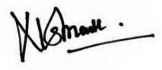



4.5 You shall during the continuance of this agreement devote the whole of your energies in business hours to the business of the company and shall in all matters act loyally and faithfully to the company and shall not engage or be interested or concerned either directly or indirectly in any other business or trade.

4.6 You shall confirm to such hours of work as are, from time to time, reasonably required of you and would not be entitled to receive any additional remuneration for work

performed outside your normal hours.

**5. Relocation/Transfer**

Your services are liable to transferred to any affiliate/subsidiary/ place of business of the company whether existing or acquired later on, anywhere in India or abroad on the same terms and condition of the employment at the sole discretion of the management.

**6. Confidentiality**

You are required to deal with the Company's money, equipment, material, software products/development, Intellectual Property Right and documents with utmost honesty, care and professional ethics. In case, if you are found guilty, at any point of time of moral turpitude or of dishonesty in dealing or taking away with the company's money, equipment, material, software products/development and documents or of theft or of misappropriation regardless of the value involved, your services would be terminated with immediate effect notwithstanding other terms and conditions mentioned in the appointment letter.

You agree that all information and items received above will be used solely as described above. All confidential information received by the recipient shall not be copied or duplicated in any way without the written authorization of the appropriate authority **"Confidential Information"** shall include all:

1. Production process, making techniques and arrangements, mailing list, purchasing information, pricing policies, quoting procedures, financial information, customer and prospect names and requirements, consultant, customer, supplier and distributor data and other materials or information relating to the company does business.
2. Computer software, whether now or hereafter existing, developed for use on any operating system of machine all modifications, enhancements and versions and all options available with respect there to and all future products developed or derived there from.
3. Source and object code, flowcharts, algorithms, coding sheet routine sub-routines and compilers, assemblers designed concepts and related documentation and manuals.
4. Discoveries, concepts and ideas including, without limitation the nature and results of research and development activities, process, formulas, inventions, computer related equipment or technology, techniques know- how, designs, drawings and specifications.
5. All other materials or information related to the business or activities of the company that are not in general known to others engaged in similar business or activities.

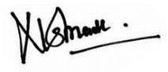



1. All ideas that are derived from or related to the employees’ access to or knowledge of any of the above enumerated materials and information.
2. All information about or belonging to suppliers and clients of, and all parties to any agreement with, the company which would be confidential information pursuant to the above definition if such other parties were in the position of the company.

6.1 All rights, titles and interests in all Confidential Information shall be and remain the exclusive property of the Company, and you agree to immediately disclose to the Company all Confidential Information developed in whole or in part by you, and to execute any instruments and to do all other things reasonably requested by the Company.

6.2 The Company’s reputation and goodwill with its clients depends on the timely and satisfactory completion of projects for the Company’s clients. You will materially breach the terms of this Letter of Appointment if you leave the Company during the transfer period, or abandons any project that you were assigned to work on for the Company’s client prior to it’ s completion. Such a breach of this contract of employment will disrupt the work at the company’s site resulting in the loss of the Company’s goodwill and standing with the Company’s client and will result in a loss of the Company’s substantial investment in you.

**7. Safeguard of Intellectual Property Rights**

Subject to any statutory provisions any invention, design or patent connected with the business of the Company either directly or indirectly invented, designed or acquired by or any improvement in any invention or design belonging to the company made by you during the continuance of your employment by the Company shall become the sole property of the company.

**8. Liability / Responsibility**

You shall be liable to compensate the Company for the entire loss suffered as to its business and goodwill in the event of the following circumstances: -

* In the event of you indulging in such activities or giving such undertaking or making a statement to a person or in public highly prejudicial to the interests of the Company.
* Under any circumstances overriding or misusing the powers possessed by you by virtue of your holding the position within the Company for your personal profits or gains.
* In the event of your stealing, misusing or misappropriating Company's property or funds handled by you.
* In the event of your incurring expenses, which are done without prior approval process

as, is in place from time to time.

l

8.1 You shall not directly or indirectly or through third party take up employment (full time or part time) with Infogain's customer, at any time, either during your period of employment with Infogain or for period of 18 months after the termination of your employment with Infogain.





8.2 You shall not engage yourself in any other gainful or commercial employment, business or activity part-time or full-time, directly, indirectly, as long as you are employed in the services of the Company. You shall not engage yourself directly or indirectly in any other profitable business connected with the dealings or activities of the Company in any way. Any failure on your part to comply with the above instructions would render your services liable for termination notwithstanding any other conditions in the appointment.

8.3 You are bound by the time commitments made by the Company to its clients in respect of assignments for the clients. You agree to honor any such time commitments, should you be assigned to assignments for the Company's clients. You further agree not to abandon any project prior to its completion and to perform your task in a manner ensuring that no disruption of work takes place.

8.4 You shall have to take prior permission from the management for joining any professional or educational course during the employment with the Company. You need to declare about the courses where you are currently enrolled in.

8.5 You shall keep us informed of any changes in your current or permanent residential addresses and any other personal particulars.

8.6 You shall be required to submit copies of your certificates and testimonials in support of your qualifications and experience.

**9. Perquisites and Activities**

9.1 Company may at its sole and absolute discretion give you certain optional perquisites/benefits during the period you are employed. You also agree to abide by the terms and conditions of these benefits. Company may alter, modify, rescind or withdraw full/partial any of the benefits administered at its sole and absolute discretion. Company assumes no responsibility in relation to any liabilities, loss damage, mishaps suffered by you in relation the optional perquisites/benefits and all the responsibilities and liabilities related to any and all these perquisites rest with you.

9.2 Company conducts optional activities and events for recreation, team building and with other company and team objectives. It is expected that you are aware of any and all risks involved in these events and activities. Company assumes no responsibility of any mishaps and accidents during these events. All the responsibilities and liabilities in

these events rest with you.

9.3 Company may carry out overall supervision for the benefits, events and activities but the same shall not be construed as Company assuming financial or other liability.

**10. Termination/ Notice Period**

In case you wish to resign from the services of the Company, you will be required to serve the full 90 days notice period to enable proper handing over/taking over and transfer of information. In case the notice period of 90 days is not given subject to applicable law, the Company may not be liable to pay any salary or benefits and issue documents/certificates.





In case you wish to leave without serving the required 90 days notice, it is up to the Company to accept early relieving and in no circumstances you being ready to pay the shortfall in notice period would be acceptable until and unless the Company's management is in agreement.

After acceptance of resignation dues settlement will take place within the timelines stated in the Separation Policy.

In the event of you having any incomplete assignment, the Company will have the discretion to relieve you only at the end of the assignment at hand. The Company also reserves the right to release you upon your resignation prior to conclusion of your notice period without paying notice pay for the balance period.

Your services shall be terminable by the Company with 90 days notice period or payment of salary in lieu of notice. The Management has the prerogative to terminate your services without any notice in the event of insubordination, indiscipline, non-performance despite warning, dishonesty, gross negligence of duty or refusal to carry out lawful instructions of your senior(s) relating to company's work subject to applicable law. Investigate of any case of insubordination, indiscipline, dishonesty or gross negligence of duty, the management at its own discretion may suspend you till the completion of investigation. During the period of suspension, the employee shall be permitted to draw half the salary. However in case the employee is exonerated of the charge, his full salary would be restored.

For the purpose of determining notice period amount, the current monthly gross salary would be taken into account.

In case you wish to leave the services of the Company prior to completion of 12 months of your joining, you shall be required to reimburse the joining expenses consisting of but not limited to Notice Pay reimbursement if any claimed by you and Relocation Expenses if any paid to you.

**11. Absenteeism**

If you absent yourself without leave or remain absent beyond the period of leave originally granted or subsequently extended, you shall be considered as having voluntarily relinquished your appointment with the company without giving any notice unless you

1. Return to work within eight days of the commencement of such absence; and
2. Give an explanation to the satisfaction of the company regarding such absence.
3. **Discharge of Duties and Obligations upon Termination/Resignation** You shall hand over all the assets of the company in good shape and condition to the authorized person of the company and obtain clearance certificate for the same.





**13. Grievances**

If you have any grievances relating to your employment you should first raise those orally or in writing with your supervisor who at his discretion may take such steps as he thinks fit with a view to settling the grievances. In case your grievances are not settled to your satisfaction, escalate the same in writing to the next level superior.

**14. Retirement**

You will be retired from service as per the existing Retirement policy.

**15. Employment/Breach of contract Agreement**

During your employment with the Company, you will be governed by the service rules and regulations of the Company in force or as introduced or amended from time to time. You will also be governed by the Company's policies and rules regarding Leave, Provident Fund, Bonus and ESI/Medical Reimbursement, Misconduct, Indiscipline or/and/other matters. Privilege leave, if encashable, will be as per Company Leave Policy.

If you commit breach of any terms of this contract, service rules or Company policies either the company will pursue all legal remedies to recover from you any damages caused due to the breach of contract and other acts detrimental to the Company's welfare / interest. Company reserves the right to change, modify any conditions stipulated in appointment letter.

**16. Jurisdiction**

For the purpose of this contract, Courts in Bangalore shall have the sole jurisdiction. You confirm that you have read, understood and taken legal advice if required before committing yourself to this offer of employment and terms & conditions, contained herein.

1. You are required to continuously maintain yourself in a state of good medical fitness so as to perform well and to discharge your assigned responsibilities adequately while in employment. You agree to submit yourself for any medical check-up at any time if

called upon by the company or its clients when assigned to work at their premises.

1. Please sign the duplicate copy of this appointment letter and return to us as your acceptance of the appointment letter.
2. If any of the statements or particulars of yourself furnished by you to the Company before or after joining the Company is/are found to be false/ misleading or unethical or your drug test report comes out positive/unacceptable or you do not co-operate in such verification or testing, the Company reserves the right to terminate your services subject to applicable law with immediate effect without any notice or any payment forthwith.

**Wishing you all the best,**

Yours Sincerely,

For Infogain India (P) Ltd.



Terms & Condition Accepted

**Rajiv Naithani**

**SVP & Global Head – HR**

**Signature of the Employee**

**Date:**



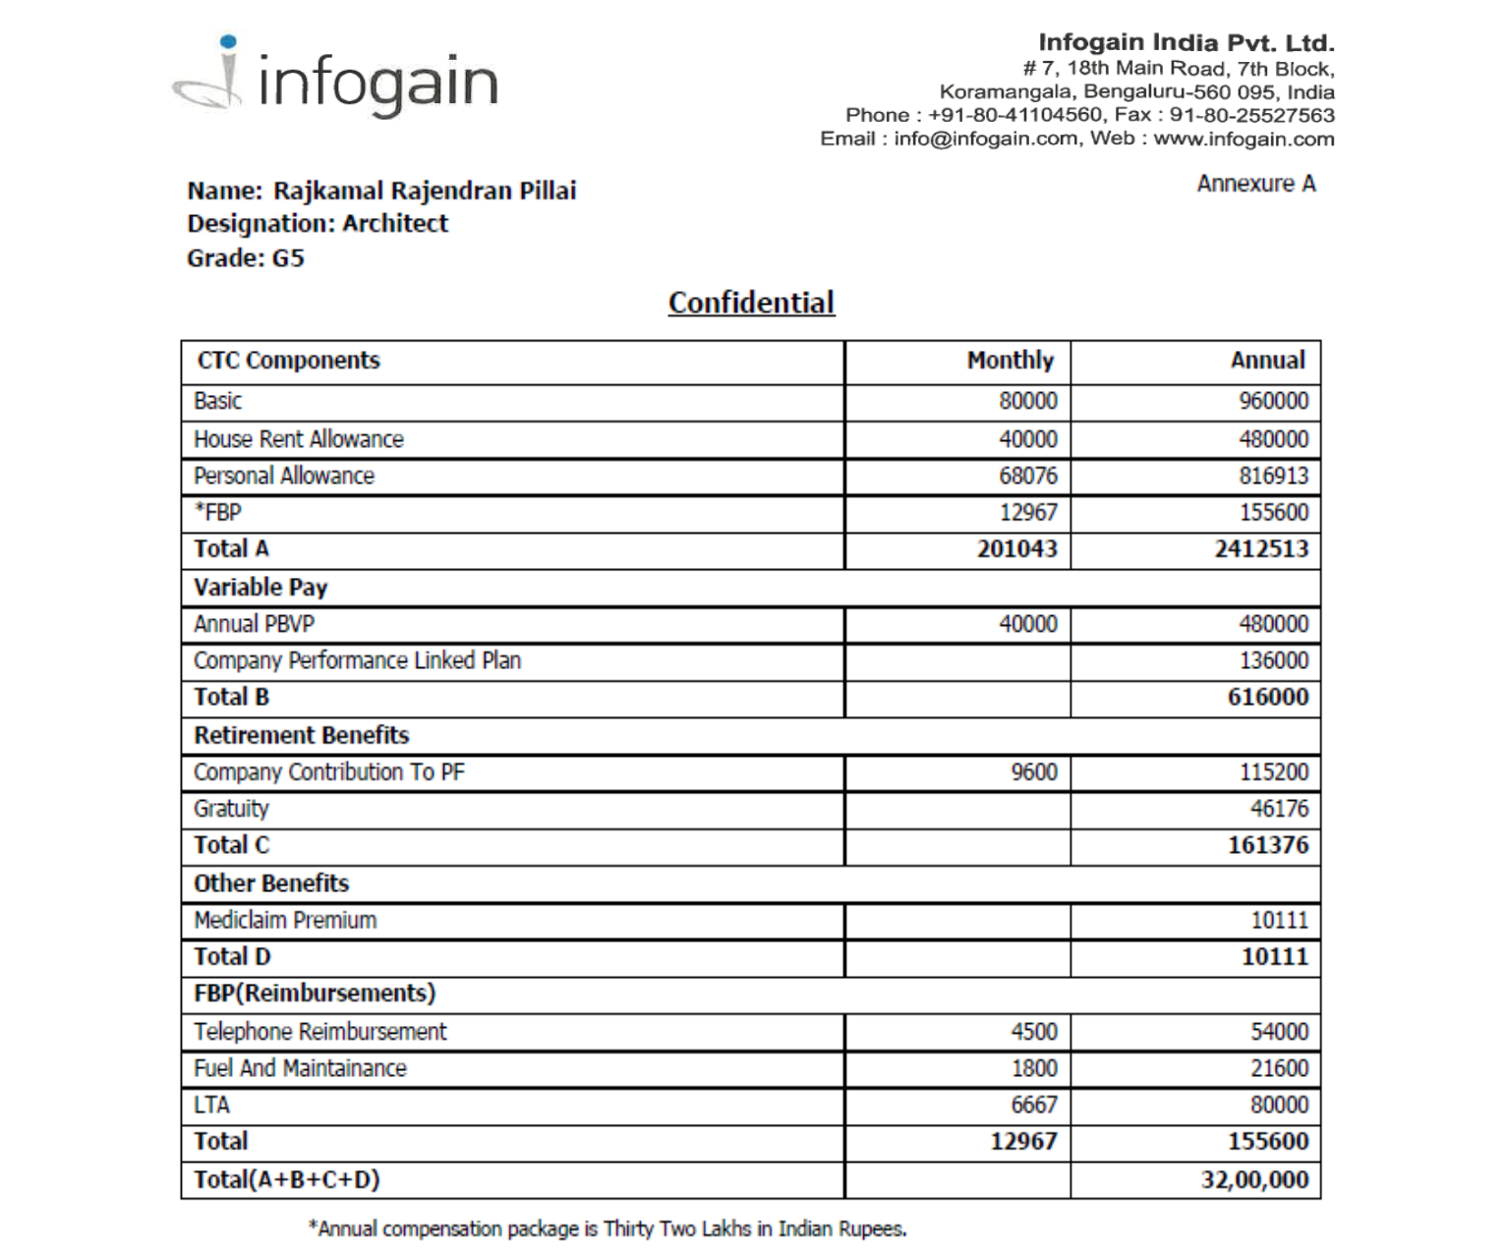

**This takes effect from 02 Nov 2020**

**for Infogain India Pvt. Ltd.**



**Rajiv Naithani**

**SVP & Global Head - HR**

**Additional Benefit:-**

Compensation including perquisites is subject to deduction of Income Tax as per Income Tax Act

**Variable Pay(if applicable): As per policy**

Mediclaim for Self, Spouse and 2 kids and dependent parents (On Nomination Basis), Accidental Insurance for individual subject to policy terms and conditions.

In addition, you will also be covered under Gratuity scheme as per the Gratuity Act.

**Please note that this is a confidential document and you are requested not to disclose the contents of the same to anyone except Human Resource Group.**

